Web Service

Web Service is a service which is delivered over the web.

It is a software system designed to support interoperable machine to machine interaction over a network.

Three Features:

1. It is designed for machine to machine interaction
2. It is interoperable
3. It should allow communication over a network.

Web Services vs Web Applications

* Web Services can be used to transfer data between Web Applications.
* Web Services can be accessed from any languages or platform.
* A Web Application is meant for humans to read, while a Web Service is meant for computers to read.
* Web Application is a complete Application with a Graphical User Interface (GUI), however, web services do not necessarily have a user interface since it is used as a component in an application.
* Web Application can be access through browsers.

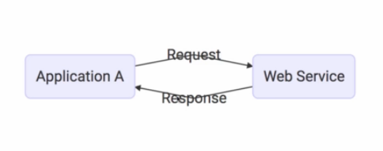

Input to a web service is request and output from a web service is response. Request and Response should be platform independent. The ways of information exchange are of two types:

1.XML(Xtensible markup language)

2.JSON (Javascript Object Notation)

Service Definition

Service Definition specifies the information exchange format and it’s structure and it’s endpoint (i.e where is this service available) to the application.

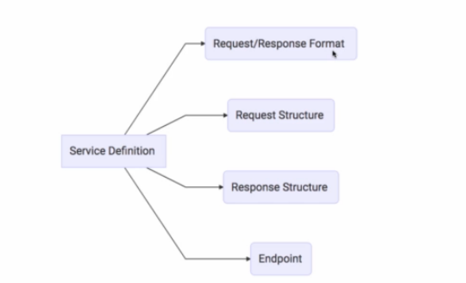

The transportation of the request and response can be done in two ways:

1. HTTP – This is done over the web(hitting/triggering a link)
2. MQ – Over the queue, application sends the request through the queue and web service would be listening the same queue it takes the request, process it and send response through it.

Types of Web Services

1. REST – It stands for Representational state transfer .It is used for communication using HTTP methods like GET,POST,PUT

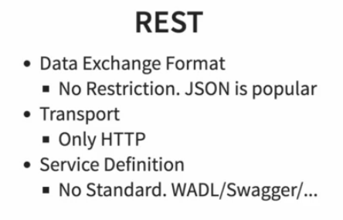

2. SOAP – It has it’s own xml message exchange format i.e SOAP xml request and SOAP xml response.

Service definition is done through web service definition language(WSDL).

In order to start with creating soap services, we have to first define structure of request and response(i.e service definition ) by creating xsd(xml schema definition).

JAXB (Java Architecture for XML Binding ) plugin is used to marshal (write) Java objects into XML and unmarshal (read) XML into objects.

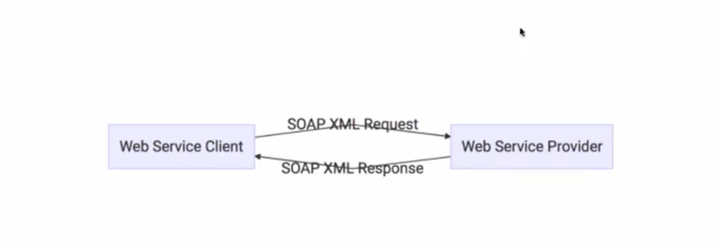

 An XML namespace is a collection of names that can be used as element or attribute names in an XML document. The namespace qualifies element names uniquely on the Web in order to avoid conflicts between elements with the same name

Steps to create soap web service:

1. Create request, response structure i.e create xsd for it.
2. Add JAXB plugin in pom.xml, provide schema and output directory and add clearOutputDir as false.(Java classes for request and response would be created by doing this).
3. Create an endpoint class(for getting and processing request and sending response) and configuration class(message dispatcher servlet is used in this configuration class, which is used to dispatch web service).

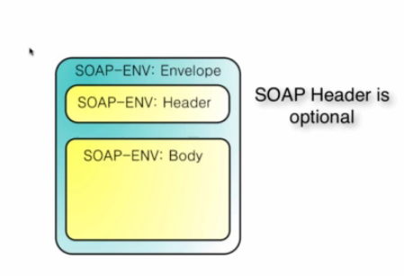

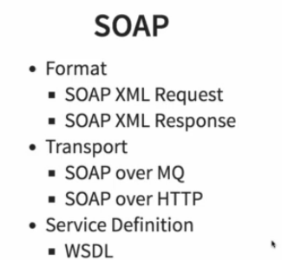

To view JSON in good format, add json viewer chrome extension in your browser.

Internationalization

Internationalization is a process that makes your application adaptable to different languages and regions without engineering changes on the source code. In other words, Internationalization is a readiness of Localization.

Code sample-

Create an instance of message resource

@Autowired

MessageSource messageSource

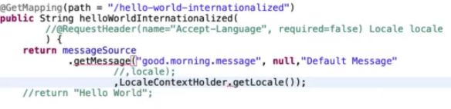

For every language we have to create new files

For default message file name is message.properties and  files for each locale should name as messages_XX.properties. The “XX” represents the locale code.

We can do content negotiation for xml using this dependency in pom.xml

If user/consumer of the API want response in the form of xml, then we can use this dependency.

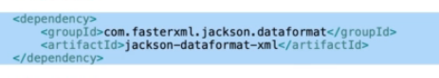

Documentation By Swagger –ui

In order to generate documentation for your API add this dependency to the pom.xml file

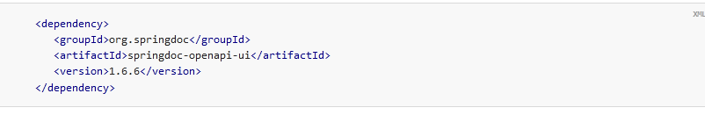

And enter this link in browser <http://localhost:8080/swagger-ui/index.html>

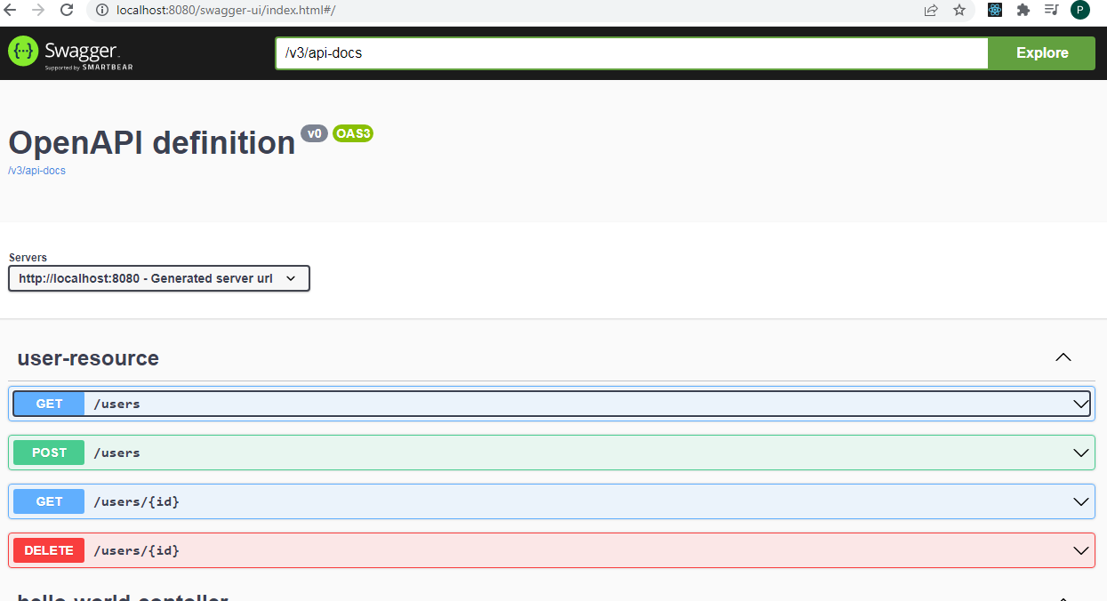

Spring Boot Actuator

Actuator brings production-ready features to our application.

Monitoring our app, gathering metrics, understanding traffic, or the state of our database become trivial with this dependency.

The main benefit of this library is that we can get production-grade tools without having to actually implement these features ourselves.

Actuator is mainly used to expose operational information about the running application — health, metrics, info, dump, env, etc. It uses HTTP endpoints or JMX beans to enable us to interact with it.

Once this dependency is on the classpath, several endpoints are available for us out of the box. As with most Spring modules, we can easily configure or extend it in many ways.

Use this dependency

<dependency>

<groupId>org.springframework.boot</groupId>

<artifactId>spring-boot-starter-actuator</artifactId>

</dependency>

We can also use HAL explorer for better visualization of the links/details provided by Actuator.

Filtering in Restful services

Filtering in restful services means when you are sending object as a response and you don’t want to send some attributes of the object, then we can use filtering i.e that attribute may contain some sensitive user information(like passwords)

Static Filtering

In the entity class , use annotation @JsonIgnore on that particular field or on top of that entity class use annotation @JsonIgnoreProperties(value={name of different fileds separated by commas})

Dynamic Filtering

This type of filtering is used when we have to filter out different fields based on different requests/responses. We can use SimpleBeanPropertyFilter and FilterProvider classes.

We can add parameter in mapping request as mentioned below:

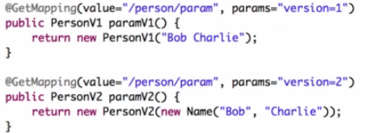

MicroServices

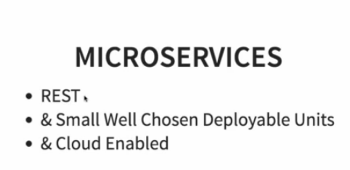

Microservices are an architectural and organizational approach to software development where software is composed of small independent services that communicate over well-defined APIs. These services are owned by small, self-contained teams.

Microservices are small deployable units of an application that communicate with each other and they are cloud-enabled(means if load/traffic for one microservices increases/decreases then cloud instance for that particular microservices can be increased or decreased).

Challenges with microservices

* It has a lot of configuration that needs to be managed.
* It should be well designed, else it will be like a pack of cards i.e if one microservice goes down the whole system crashes.
* Dynamic scale-up/scale-down should be possible depending on the traffic.

SPRING CLOUD

Spring Cloud provides tools for developers to quickly build some of the common patterns in distributed systems (e.g. configuration management, service discovery, circuit breakers, intelligent routing, micro-proxy, control bus, one-time tokens, global locks, leadership election, distributed sessions, cluster state). Coordination of distributed systems leads to boiler plate patterns, and using Spring Cloud developers can quickly stand up services and applications that implement those patterns. They will work well in any distributed environment, including the developer’s own laptop, bare metal data centres, and managed platforms such as Cloud Foundry.

<https://spring.io/projects/spring-cloud>

Advantages of Microservices

* Since microservices are small, independently deployable units they can be created using different technologies.
* It can also be dynamically scaled up or down depending on traffic.

In order to fetch values from application.properties file

Create a class Configuration and use annotation on top of it as @ConfigurationProperties(“name of variable in application.properties”)

And create it’s variables and its’s getter and setter.

For example-

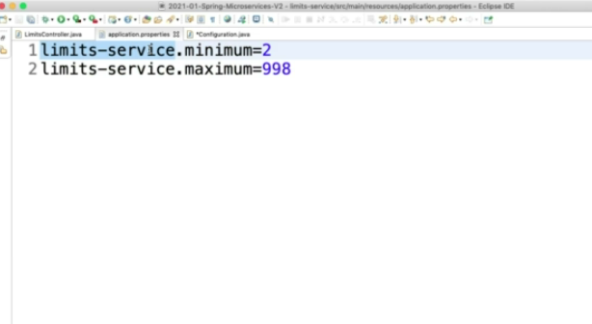

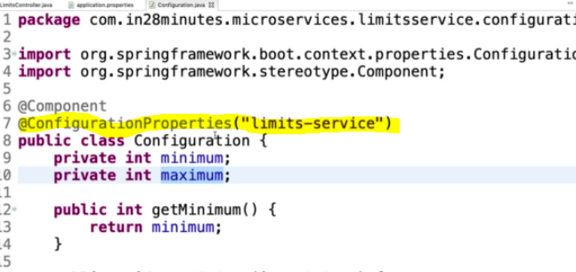

To get environment related details(like port number) we can create instance of Environment and access it’s method

We may also import configuration details from different microservices by using some configuration as mentioned below:

Config Server Application which takes values from git repo

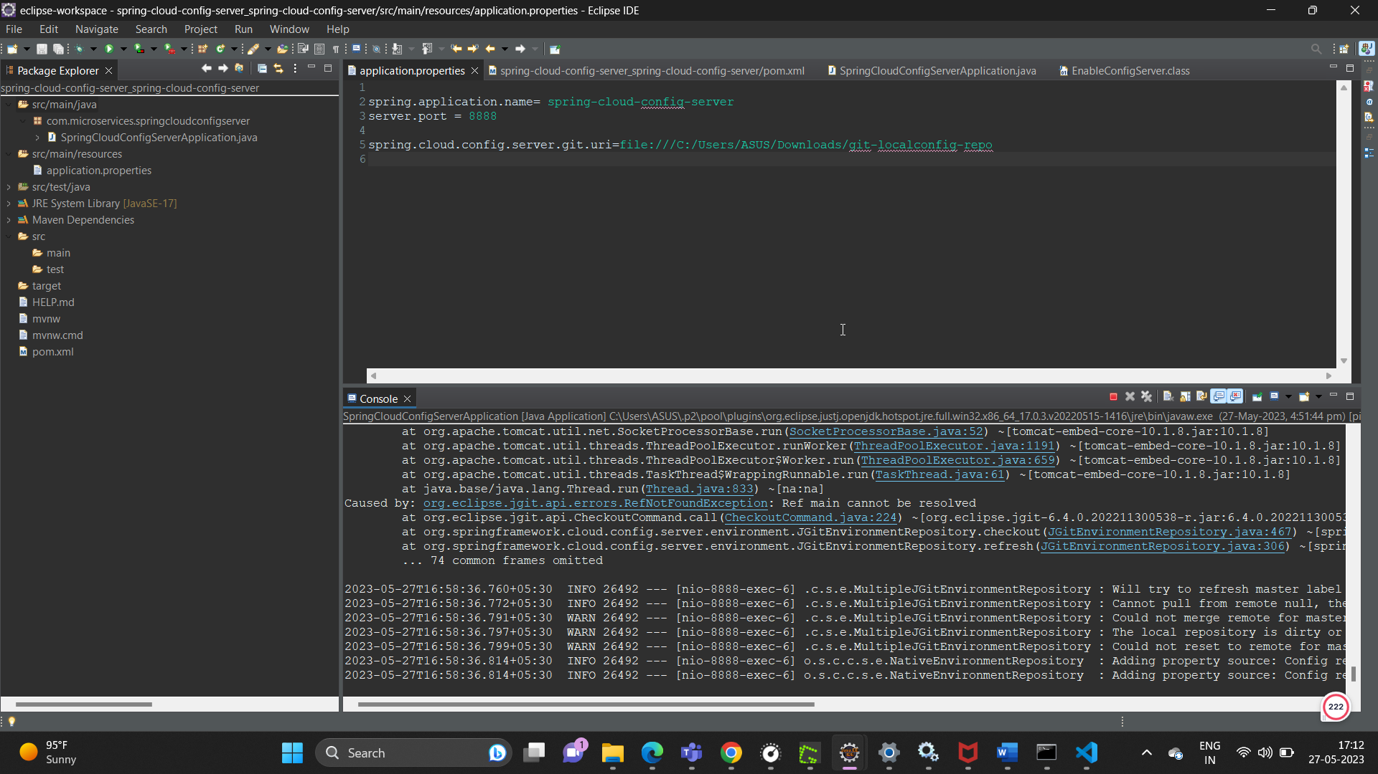

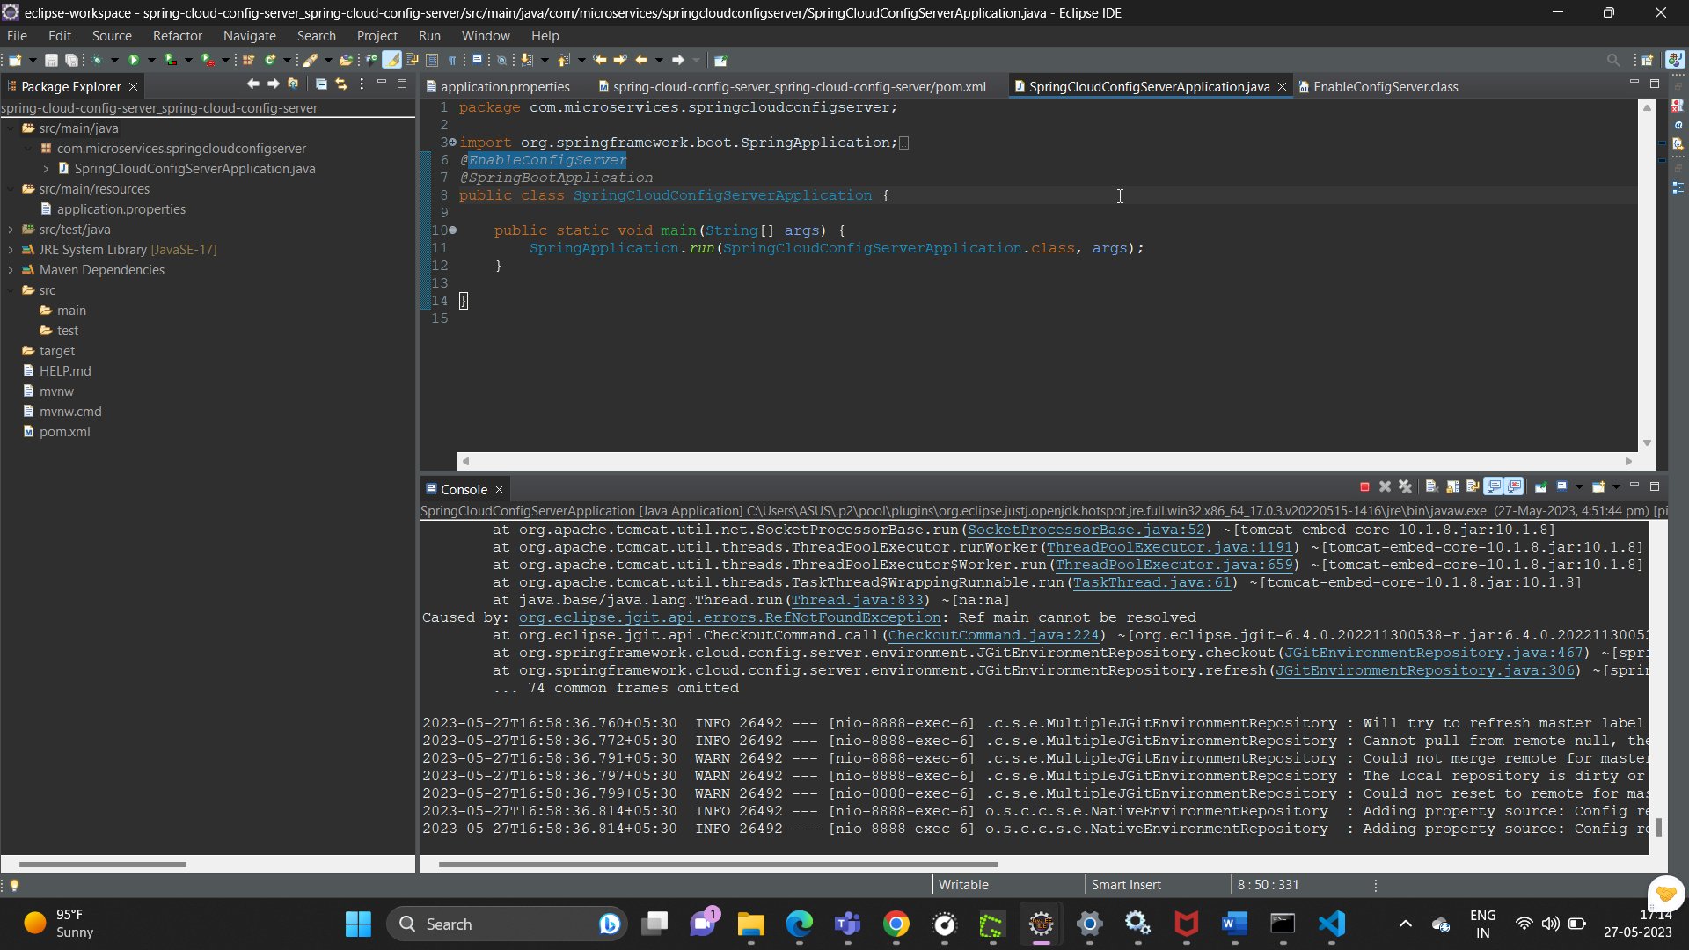

Limits-service which takes values from config server

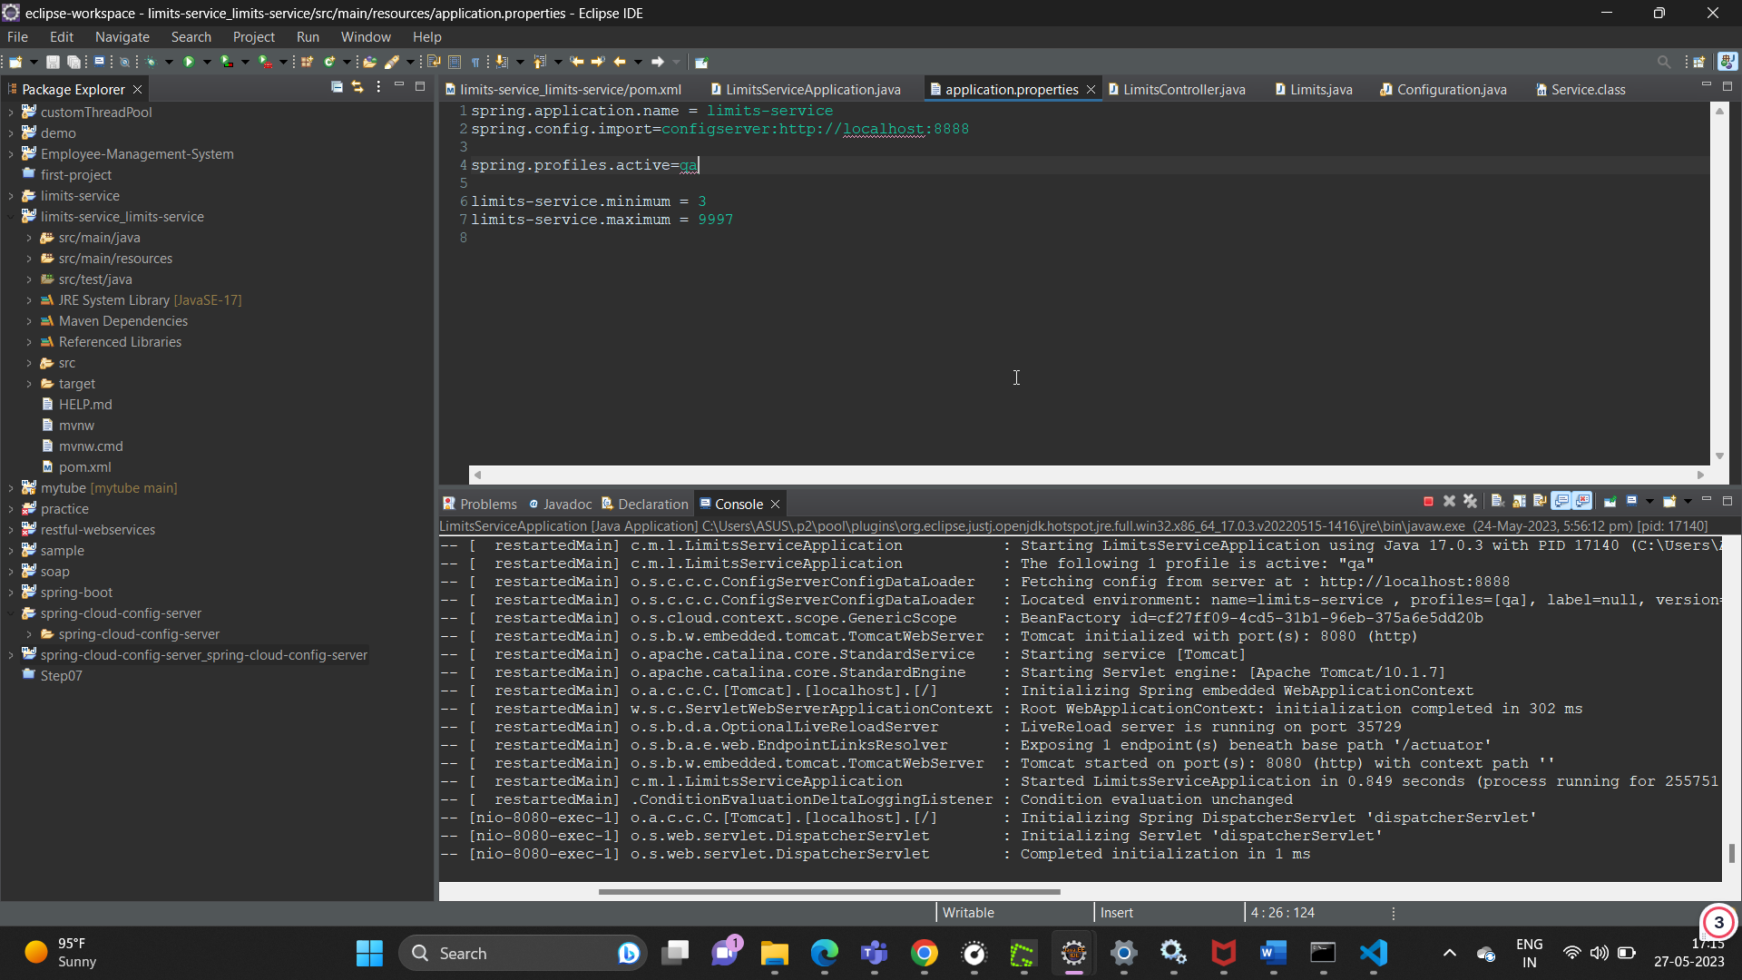

Run same application on different instances, we may open this window by using Run->Run Configurations

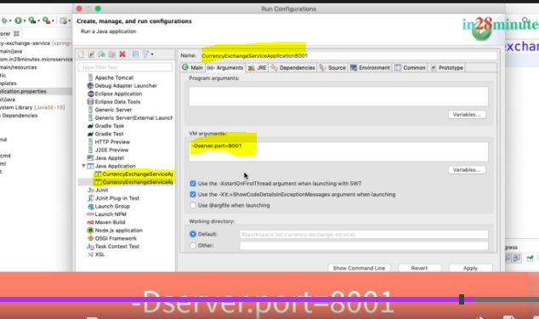

We can also give to name to our application by using property

spring.application.name = <name of application>

spring.jpa.defer-datasource-initialization=true

it means that data.sql file should be executed only after table creation, if we don’t write this statement then it will give table not found exception.

We can make a call from one microservice to another by using the following as displayed below:

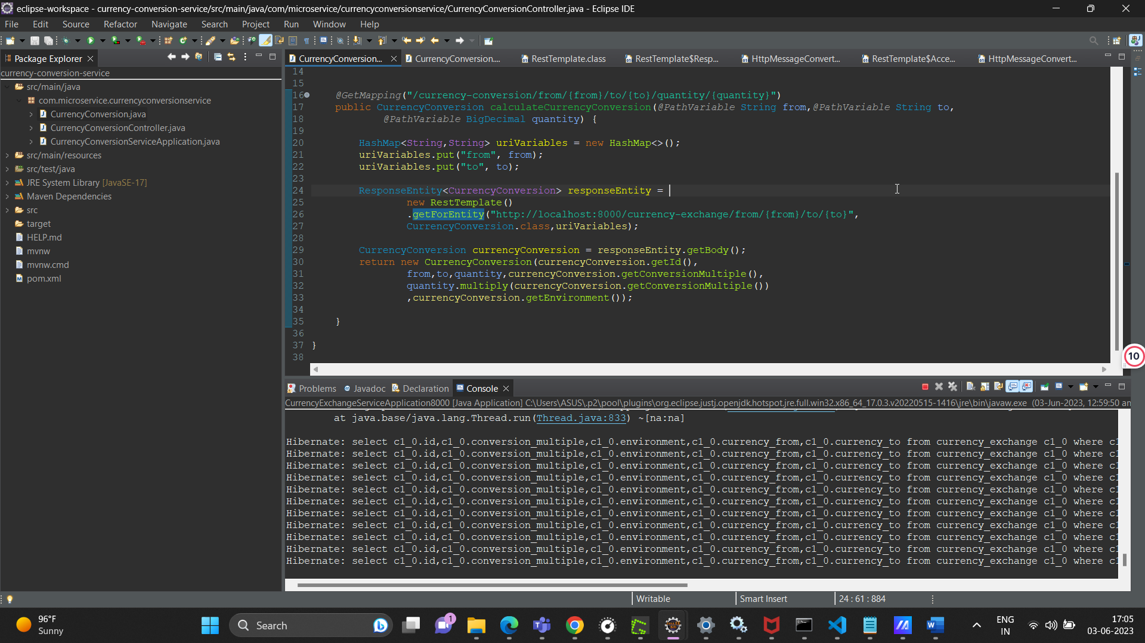

Feign in Spring Cloud

We can make a call to another microservice by rest template but this very tedious task(as displayed above) instead we can make use of Feign.Feign makes it very easy to make a rest call from one microservice to another.

To add feign we have to add this dependency

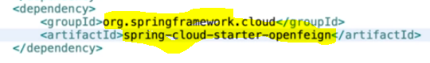

We have to make a interface as displayed in the below picture and use this method directly in our class (by making instance of this interface), as highlighted we just have to give the application name, it’s url, it’s mapping. We also have to use this annotation @EnableFeignClientson top of main class , it helps in scanning all the feign clients.

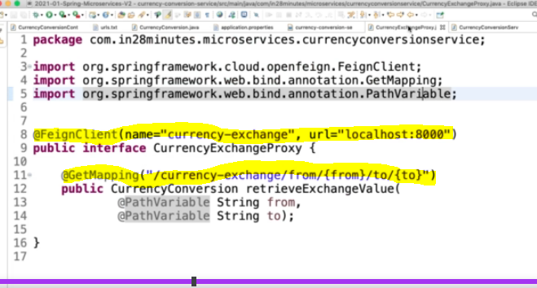

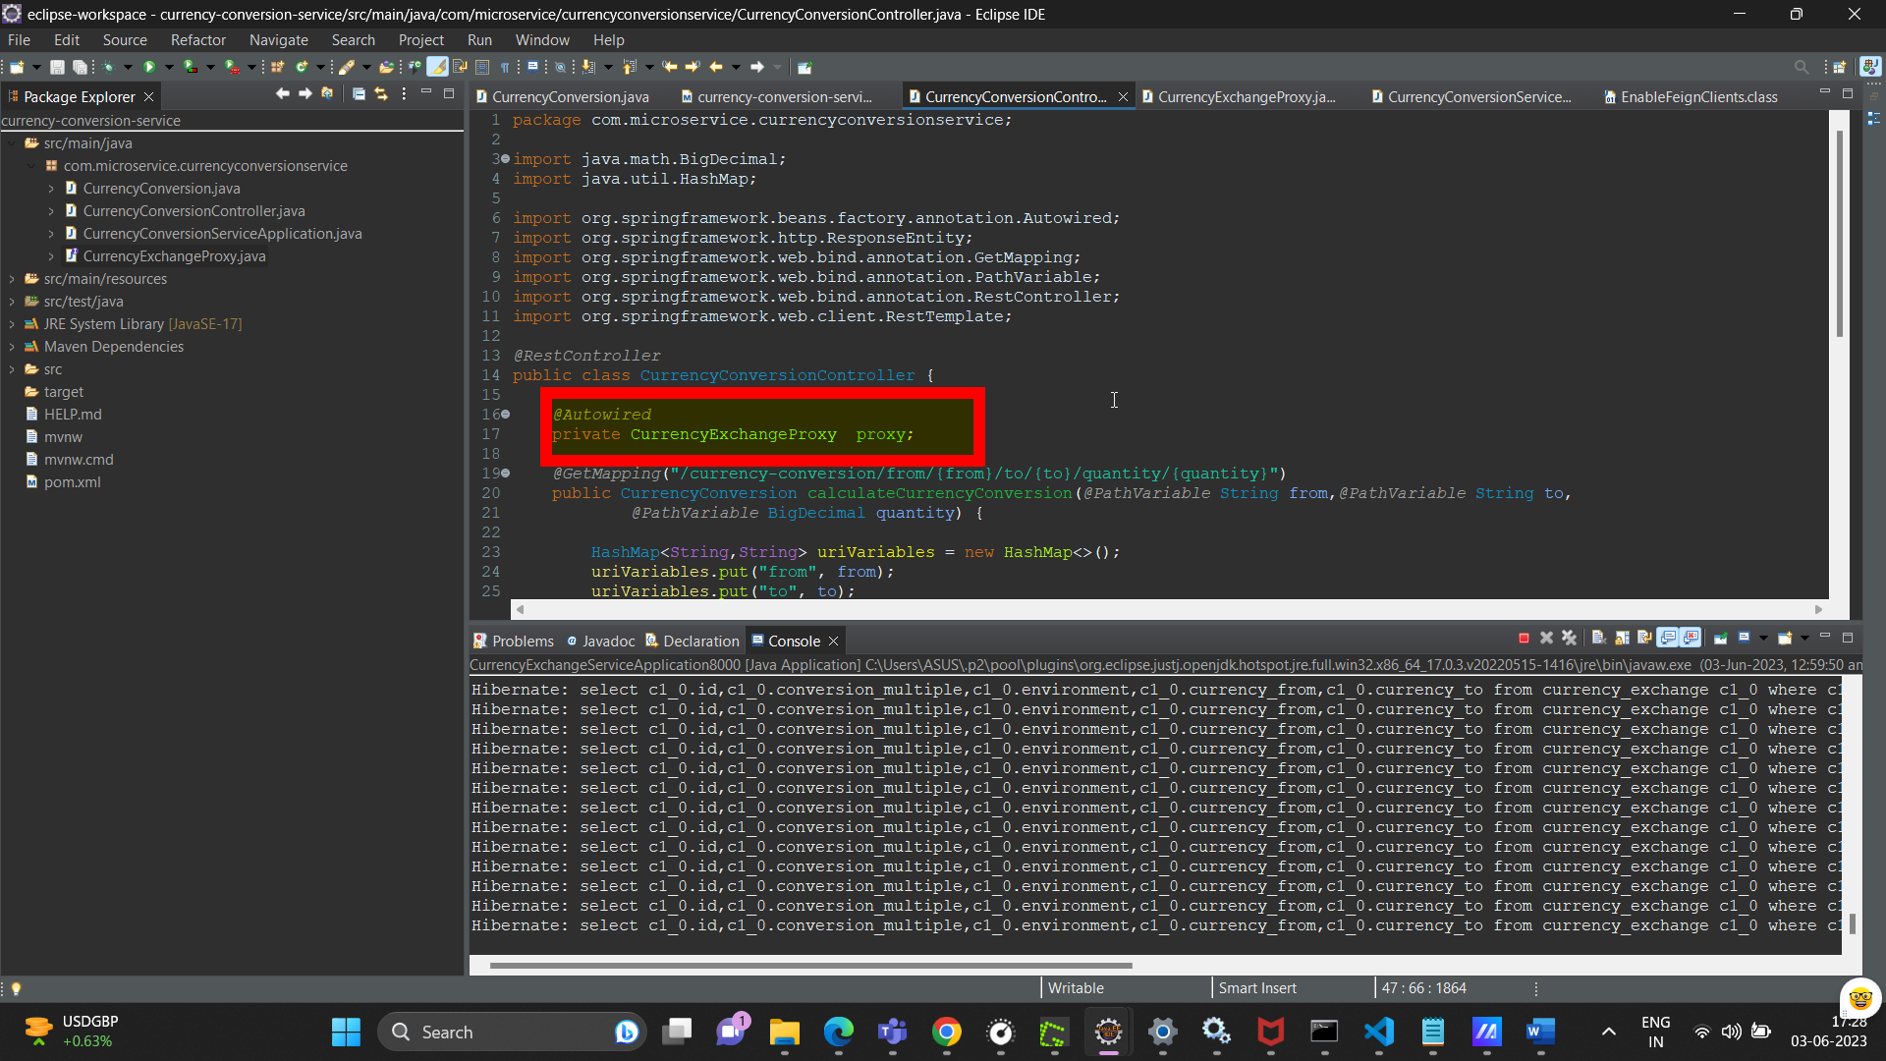

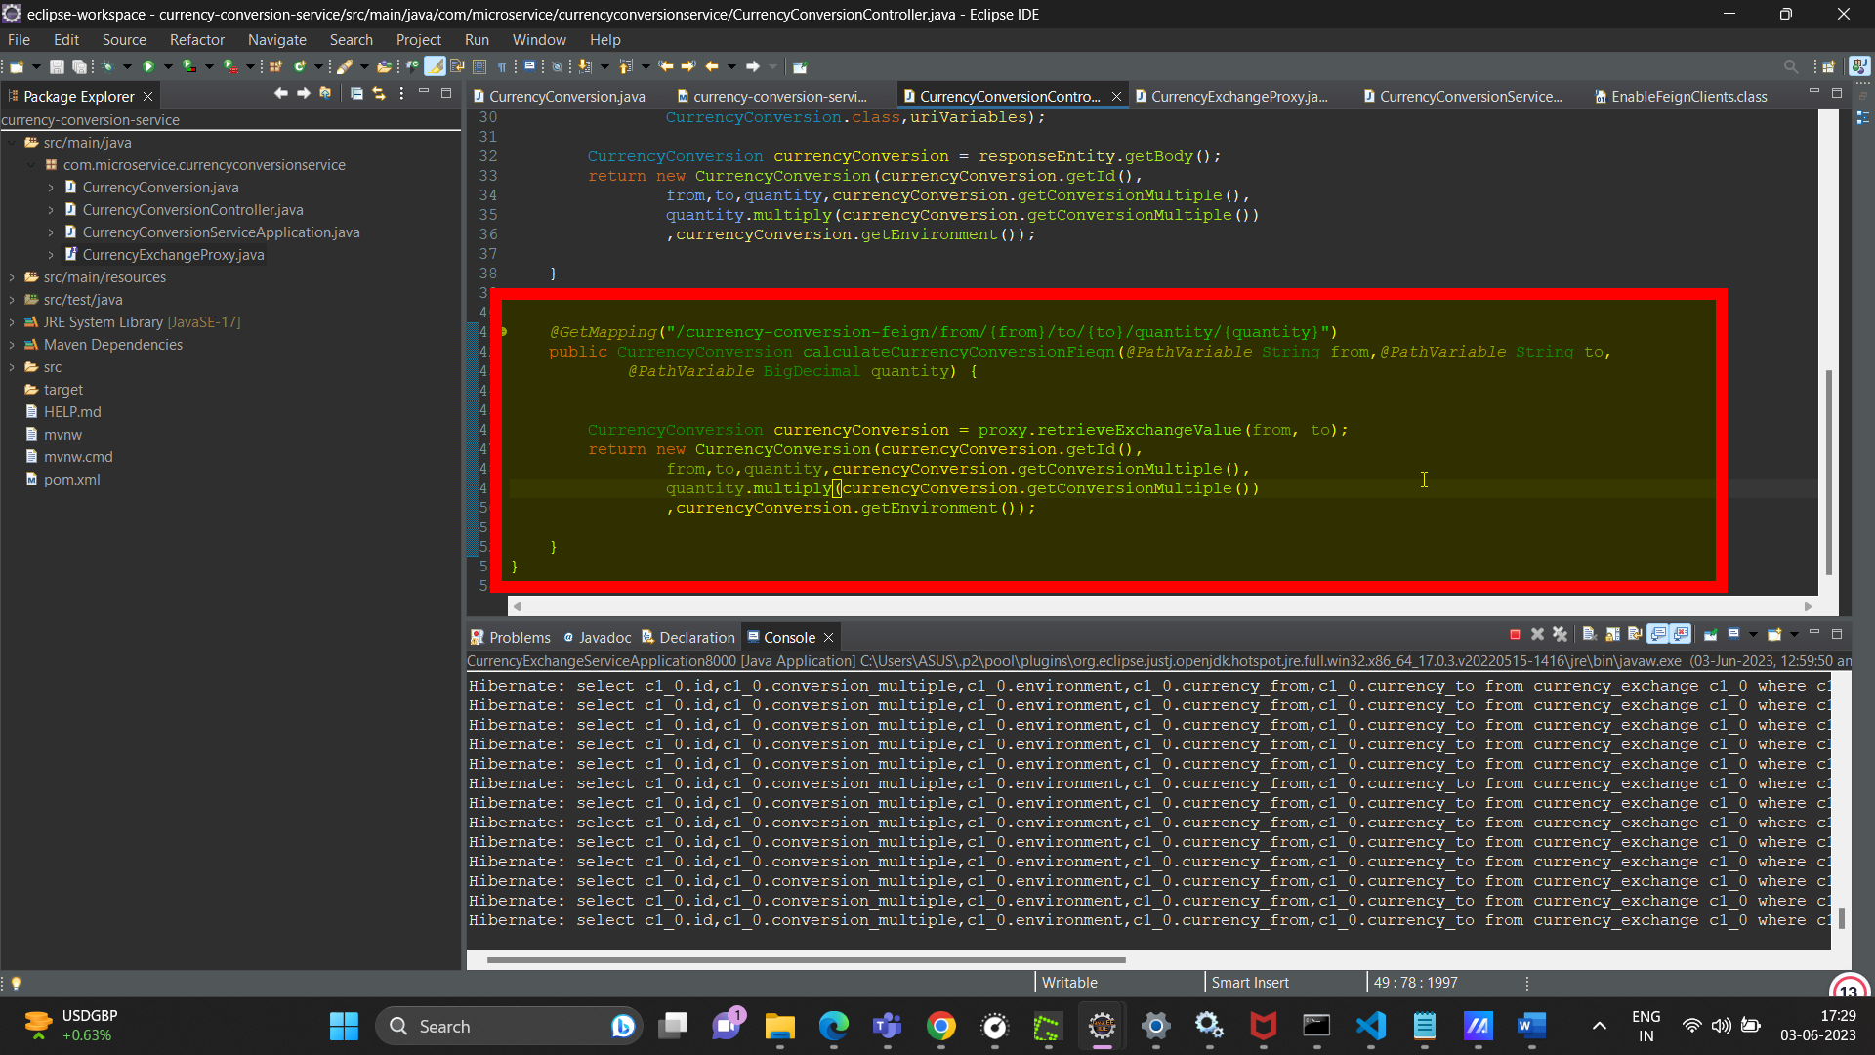

In order to avoid using hardcoded urls we use Eureka naming server.

Eureka naming server keeps track of all the hostnames and port names of different application.The applications do not have hardcoded URLS, they fetch the urls of microservice that they want to communicate from eureka naming server. It also helps in load balancing. It uses this dependency and @EnableEurekaServer on top of the main class of the application and the below displayed configuration.

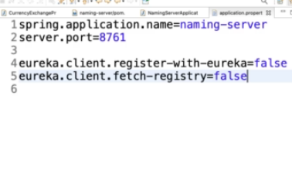

<dependency>

<groupId>org.springframework.cloud</groupId>

<artifactId>spring-cloud-starter-netflix-eureka-server</artifactId>

</dependency>

And the corresponding client uses this dependency.

We can register the application to naming server using this dependency and adding a configuration as mentioned below in application.properties.

<dependency>

<groupId>org.springframework.cloud</groupId>

<artifactId>spring-cloud-starter-netflix-eureka-client</artifactId>

</dependency>

We can also specify which naming server application would be using and provide it’s url in application.properties

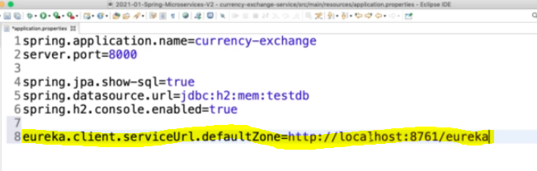

API gateway

Spring Cloud Gateway aims to provide a simple, yet effective way to route to APIs and provide cross cutting concerns to them such as: security, monitoring/metrics, and resiliency. In order to enable the api gateway to talk to eureka naming server in order to fetch the urls or port number use the property as mentioned below:

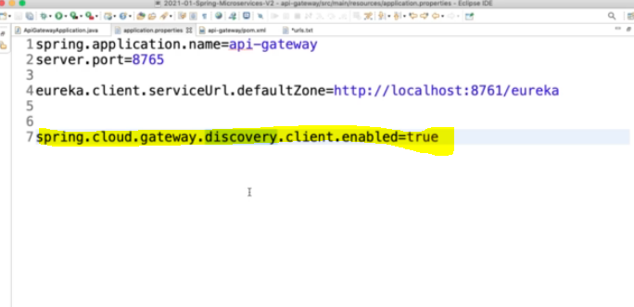

So currency-exchange microservice which is registered with eureka can be accessed using api gateway using the following url

<http://localhost:8765/CURRENCY-EXCHANGE/currency-exchange/from/USD/to/INR>

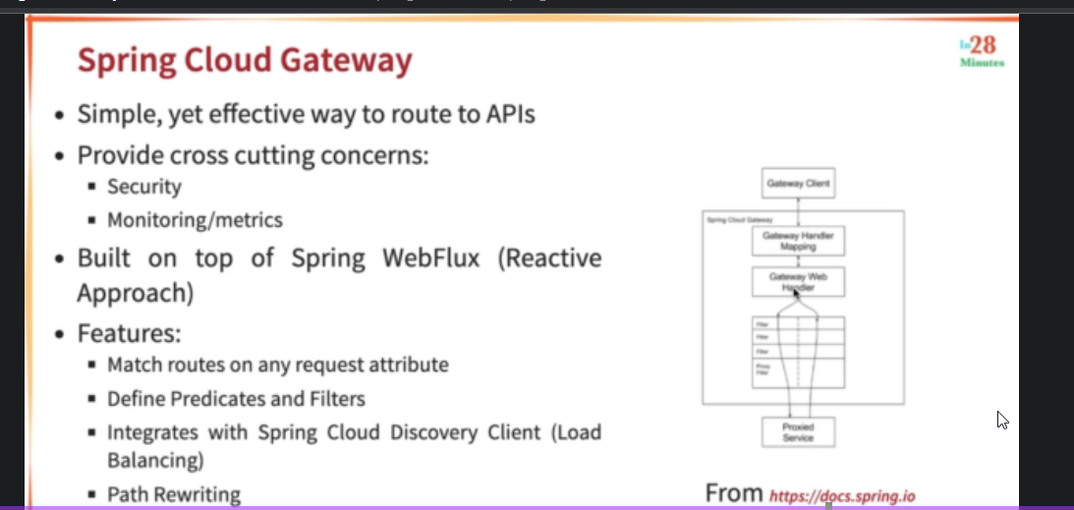

Resilience4j

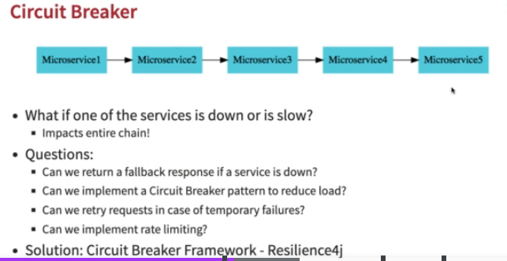

@Retry

Can be used to retry hitting the same service if it’s execution failed due to some unexpected condition. We can also give fallback response as mentioned in the below picture.

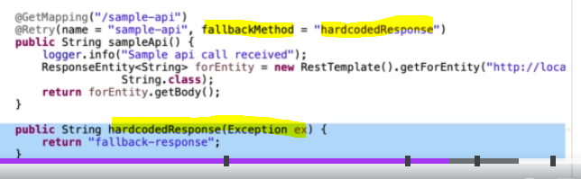

@CircuitBreaker

We can also use this annotation to break the circuit, after a request fails for certain times, circuit breaker starts giving default response without even hitting the service.

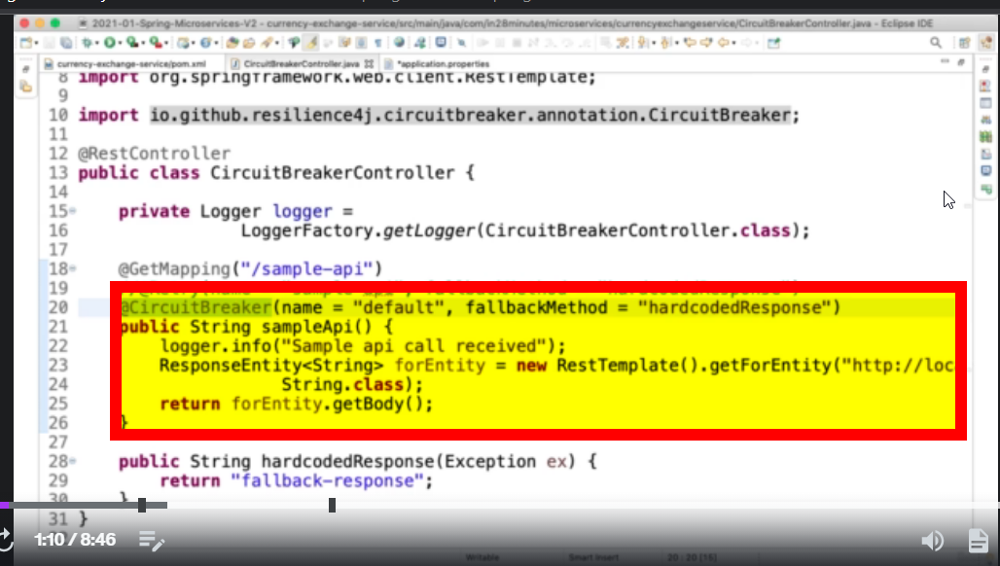

We may use watch command to send a lot of request to a microservice at once

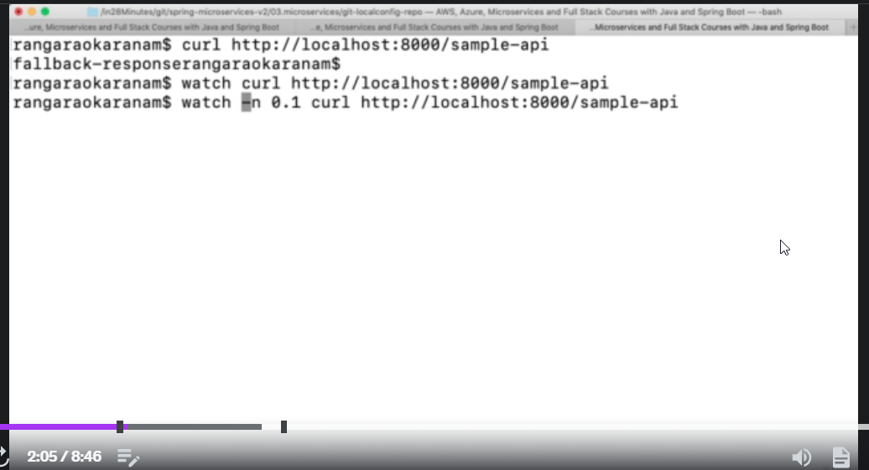

Rate Limiting

There is a feature in resilience4j known as rate limiting, that limits the number of request that a particular microservice receives. @RateLimiter annotation is used for it.

Bulkhead

This is another feature of resilience4j that limits the number of concurrent call to api,@Bulkhead annotation is used for it.

Dockers

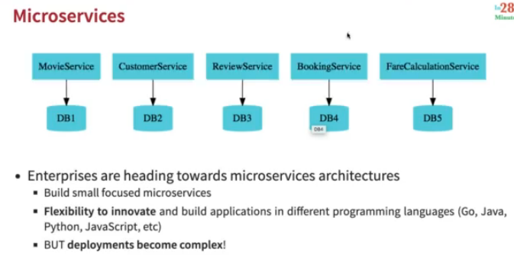

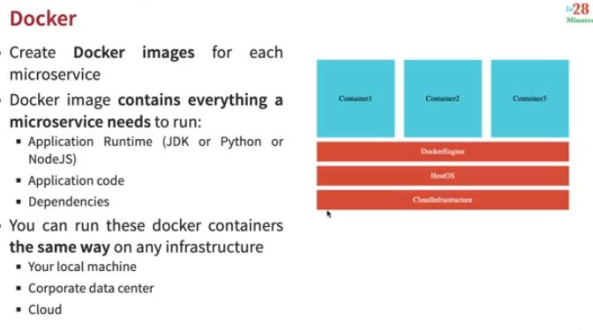

Command 🡪 docker run applicationName:version

This command creates a bundle of all the libraries and creates an application image and this image is downloaded and run on your machine.

Image is a set of bytes and running version of this image is called Container. For same image , we can have multiple version running.

Image is static version of container. Image is like a class and Container is like a object.

docker run –p {HostPort}:{ContiainerPort} applicationName:version(this extra things in the command indicates mapping between hostport and container port , because we can’t access docker internal network)

Docker.hub.com is a registry and a registry may contain many repository

To download docker images

Command -> docker pull image_name(This command only downloads the docker image, it does not run it)

To see all the docker images

Command 🡪 docker images

To get metadata about running containers

Command 🡪 docker container ls

To stop a container

Command 🡪 docker container stop <container_id>

To get history of a image(It displays steps in creating the image)

Command 🡪 docker image history <image_id>

To remove docker image from local

Command 🡪 docker image remove <image_id>

To pause a container

Command 🡪 docker container pause <container_id>

To unpause a container

Command 🡪 docker container unpause <container_id>

To get Details(metadata) of a container

Command 🡪 docker container inspect <container_id>

To see which processes are running in a container

Command 🡪 docker top <container_id>

Docker Architecture

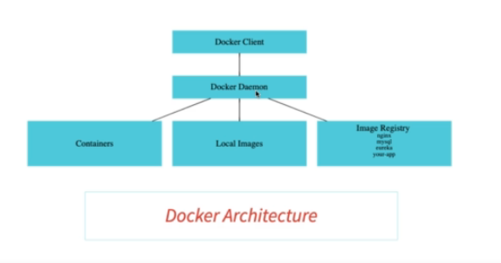

https://docs.docker.com/get-started/overview/

Distributed Tracing

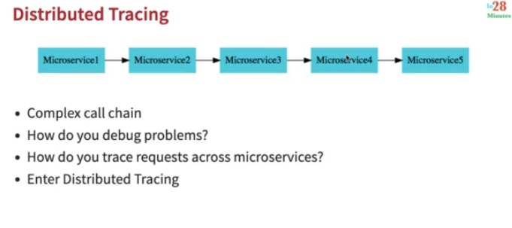

All the request from all the micro services are sent to a single distributed tracing server, which in turn are sent to database. Example of distributed tracing server is zipkin. It can be launched with the help of a container.

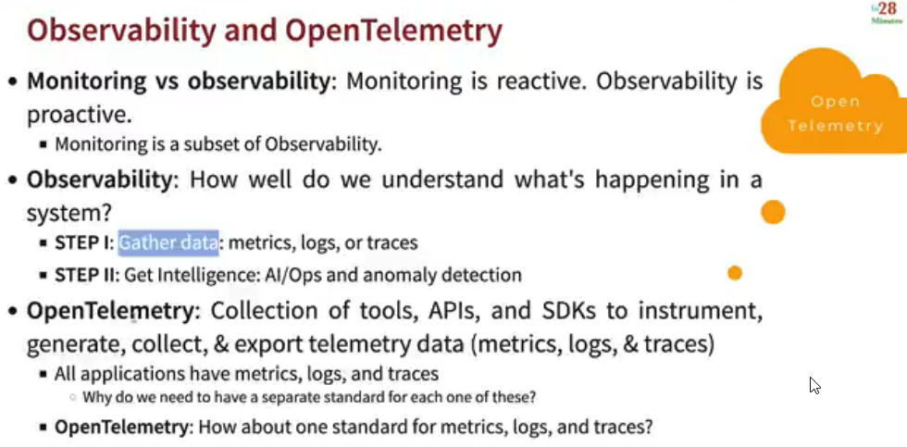

We use the following maven build , goals to create docker image of a microservice.

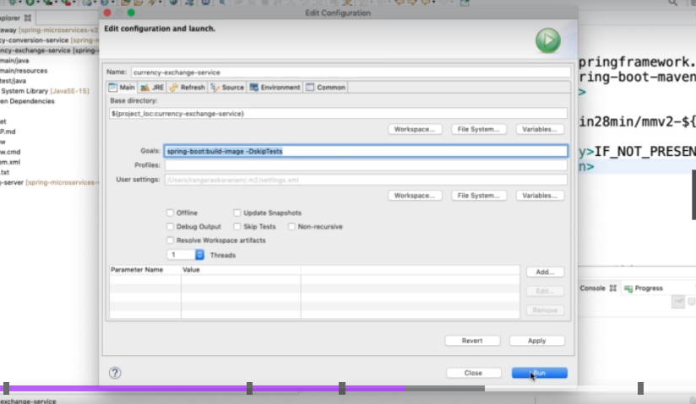

In order to create a docker image of a microservice, we need to add some configuration for spring-boot-maven-plugin in pom.xml

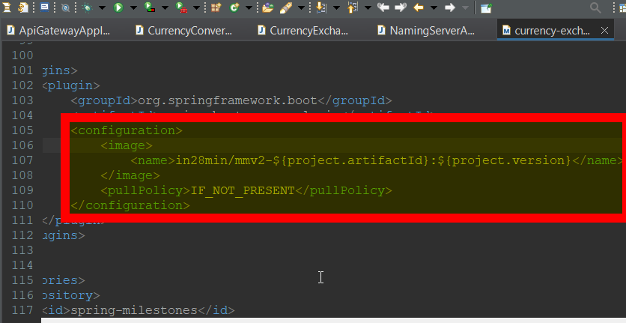

in28min is the docker hub, it contains multiple images, with their version

pullPolicy here means that it will pull the image only when it is not present locally.

Docker Compose

<https://docs.docker.com/compose/>

Docker Compose helps in running multiple docker containers easily by using yaml configuration file.(as displayed below) by providing the image name, port number etc.

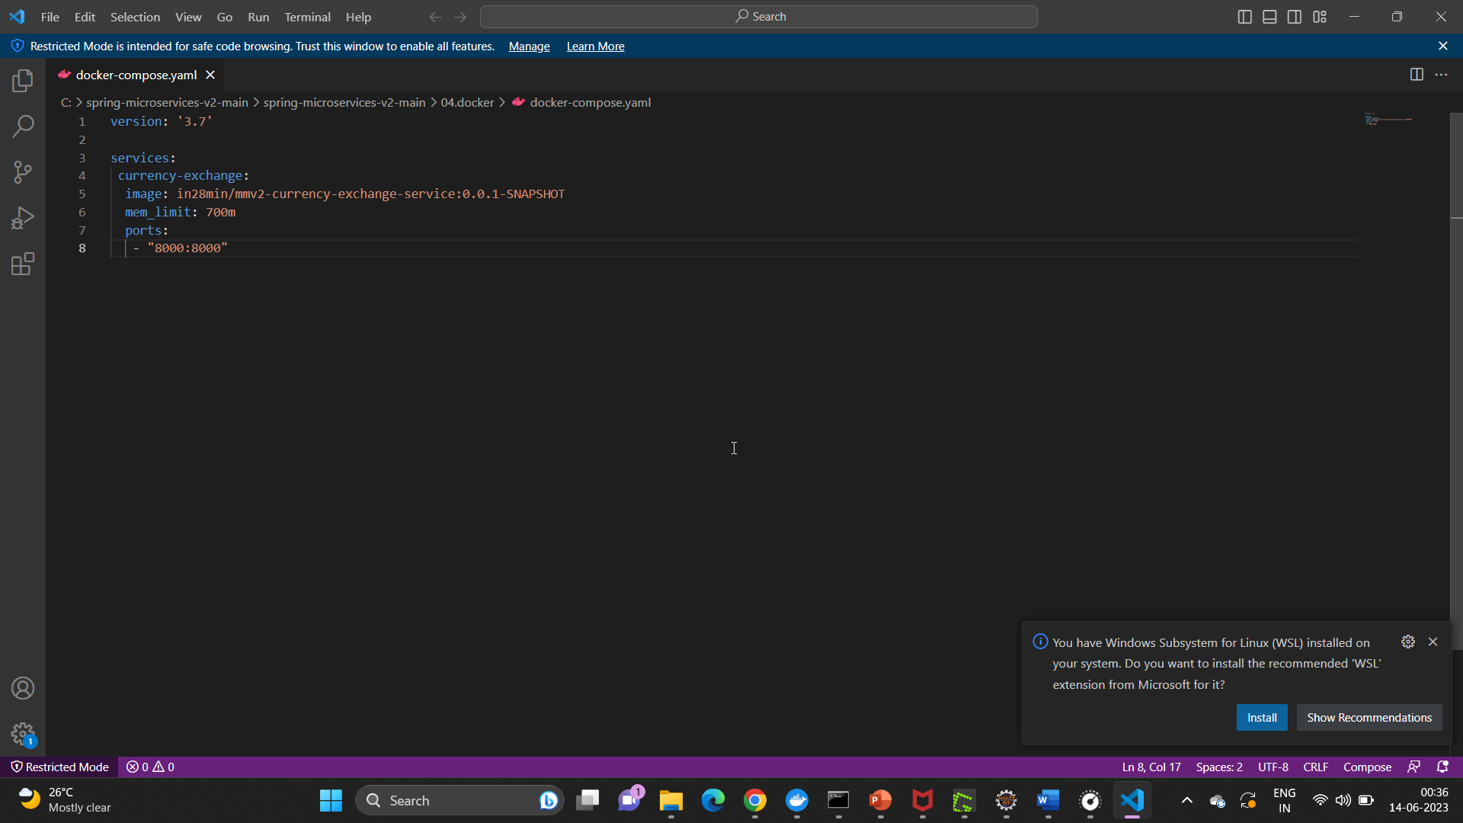

We may also run docker images by using docker run command, but docker compose provide a better way to run these application.

We just have to provide configuration in docker-compose.yaml file and run “docker-compose up” command.

Architecture of Distributed tracing

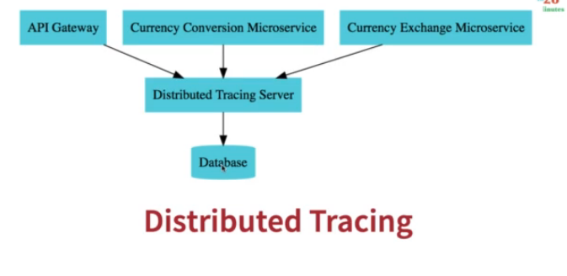

Recommended Architecture of Distributed tracing

The below architecture is recommended, in case distributed tracing server is down, all the request from the micro services goes to rabbit mq(gets stored in this queue) and when the distributed tracing server is up and running , it picks up request from these queue.

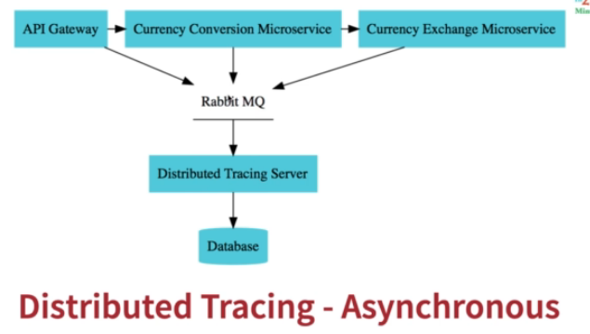

Kubernetes

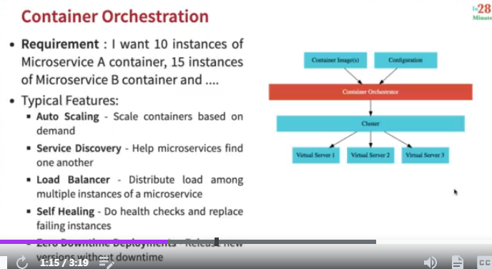

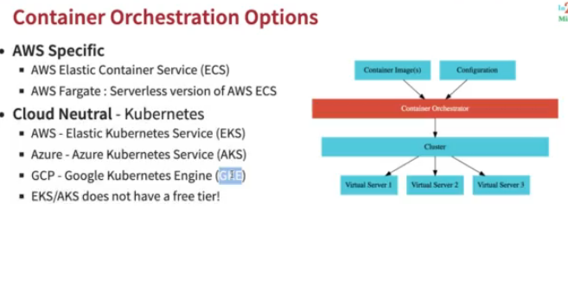

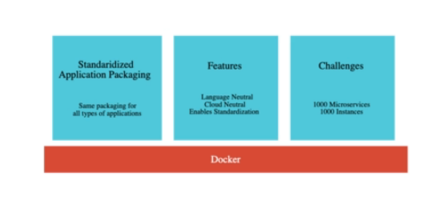

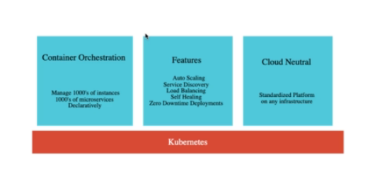

Kubernetes manages resources i.e. it manages servers, these servers are in the cloud so they are virtual servers.

A cluster is a combination of nodes and master nodes.

There are two types of nodes in the cluster:

1. Master nodes – These manage the cluster.
2. Worker nodes – These help in running the application.

There are some fun facts regarding Kubernetes(also known as K8S)

It is pronounced as KOO-BER-NET-EEZ.

Kubernetes(Greek word meaning helmsman of a ship) logo depicts that someone is providing direction to a ship.

Kubernetes on cloud – AKS, Amazon EKS and GKE

We need to create cluster in Kubernetes engine

In order to deploy spring boot application on Kubernetes , we may use command line present inside the cluster.

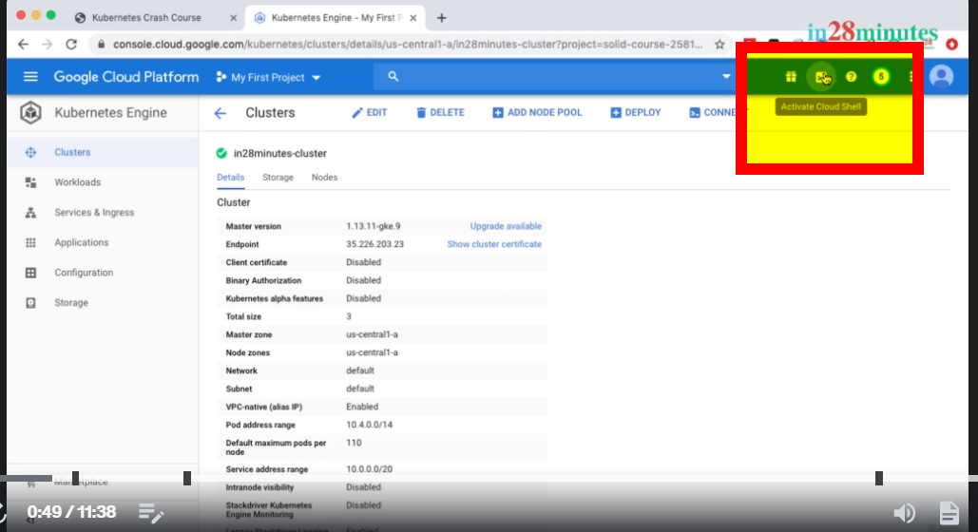

We use this command to connect to the cluster

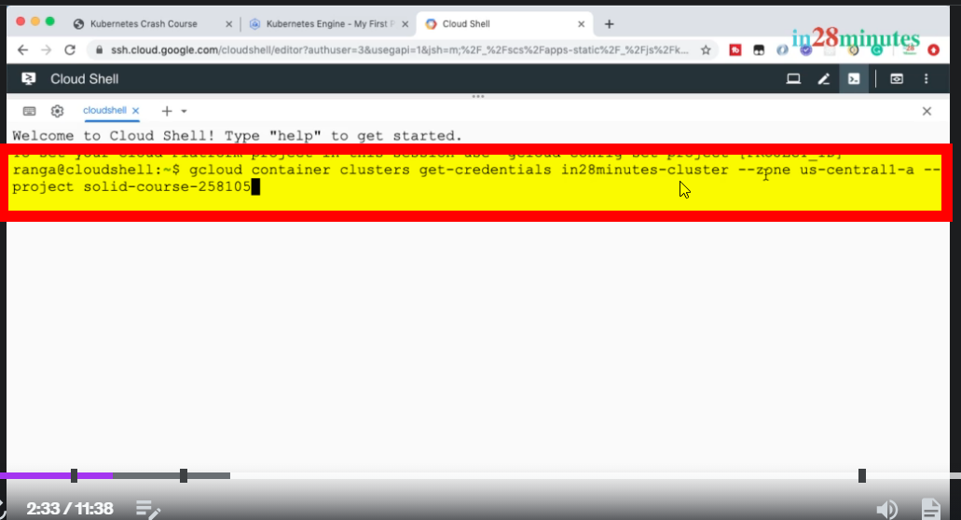

The above-mentioned command can be generated from the button below:

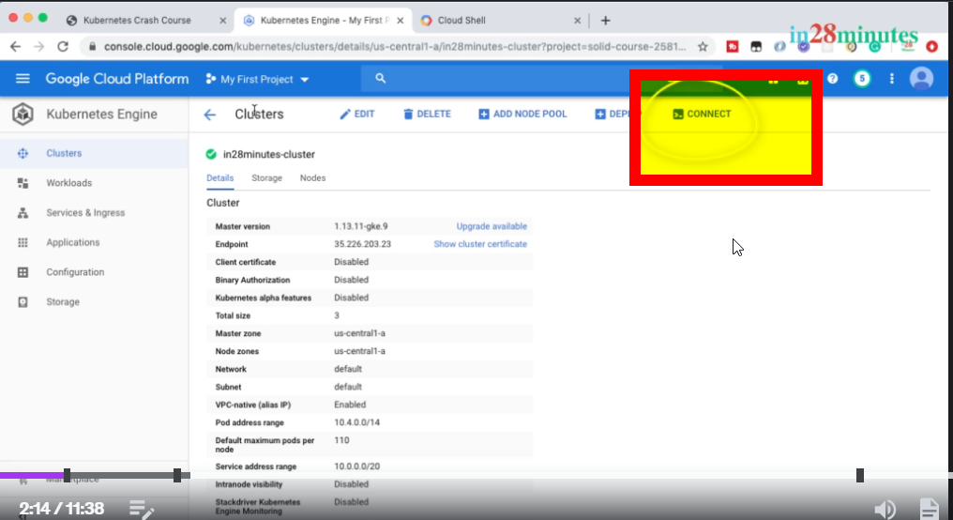

kubectl – It is a kube controller, which is used to interact with the cluster. This is used in several Kubernetes command.

After connecting with Kubernetes cluster, we deploy the docker image to the cluster by using command as mentioned below:

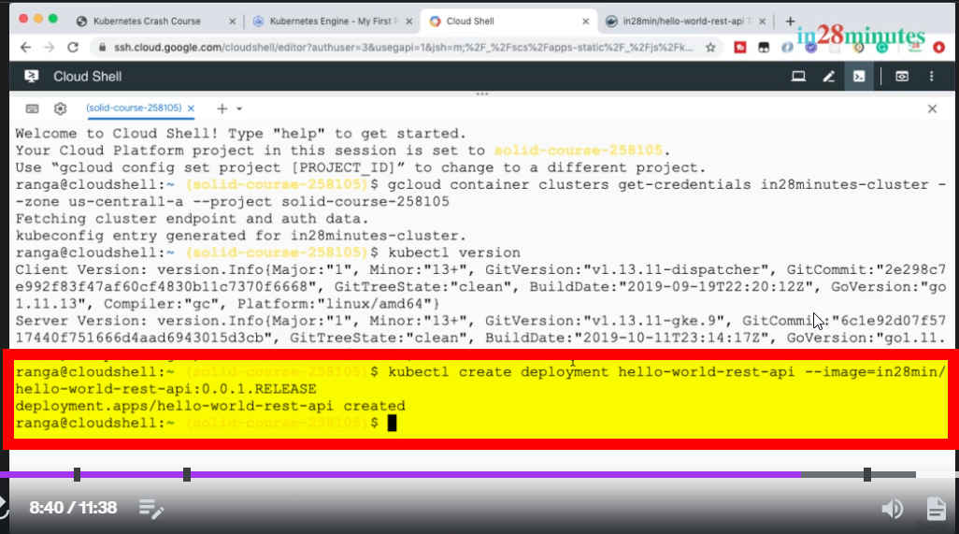

After the above mentioned command is executed, we expose this deployment to the outside world i.e by specifying it’s type and port number.

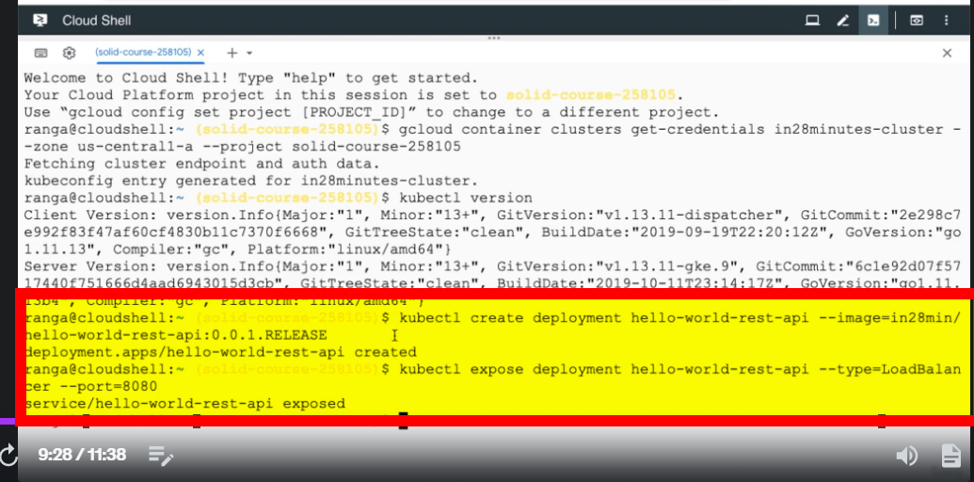

kubectl get events – This is used to check what happens in the background when we deploy application to Kubernetes.

Kubernetes uses a single responsibility principle i.e one term will have one responsibility.

POD

A pod is the smallest deployable unit in Kubernetes.

You might think containers are the smallest deployable unit,

but no, in Kubernetes the smallest deployment unit

is actually the pod. The container lives inside a pod.

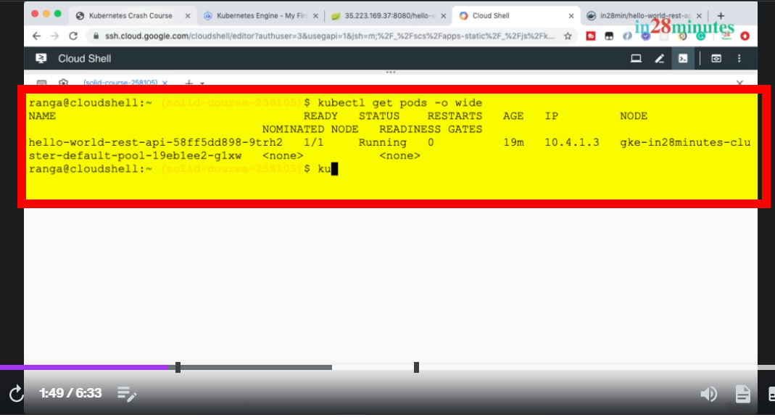

Each pod has a unique IP address.

The other thing which you are seeing in here

is the one by one,

which is the number of containers

that are present in that specific pod,

and how many of them are ready.

A pod can actually contain multiple containers.

All the containers which are present in a pod

share resources.

Within the same pod,

the containers can talk to each other using local host.

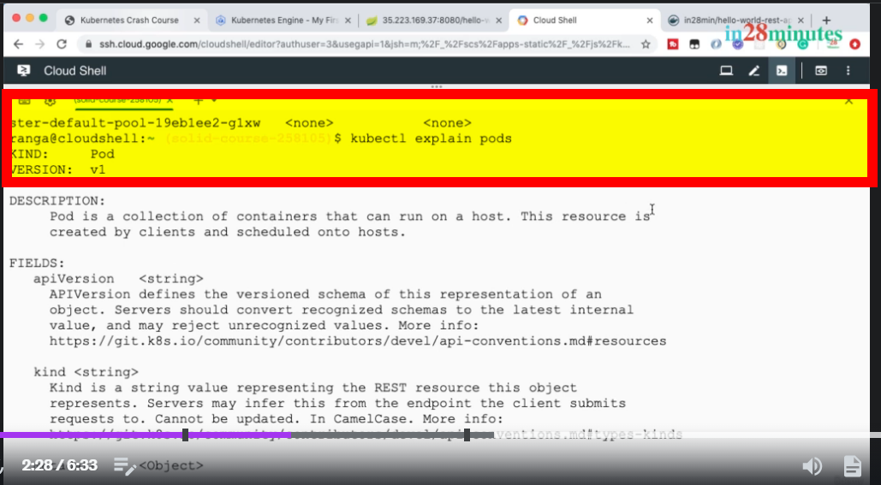

A pod in Kubernetes is a collection of containers.

So a pod can contain multiple containers

that can run on a host,

that can run on a single node.

This resource is created by clients

and scheduled onto hosts.

So what we are understanding is the fact

that a Kubernetes node can contain multiple pods,

and each of these pods can contain multiple containers.

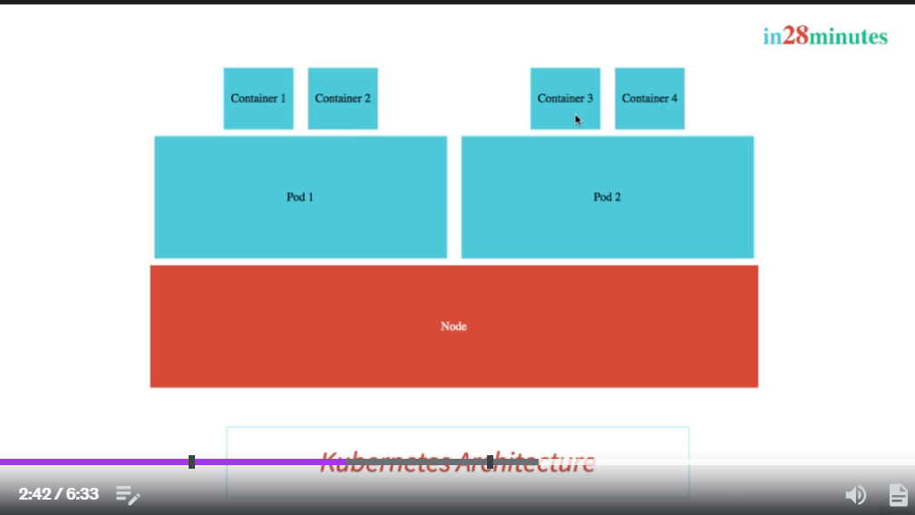

Kubernetes nodes can contain multiple pods, which in turn contain multiple containers.

In order to get in-depth information about pods, we may use the below command.

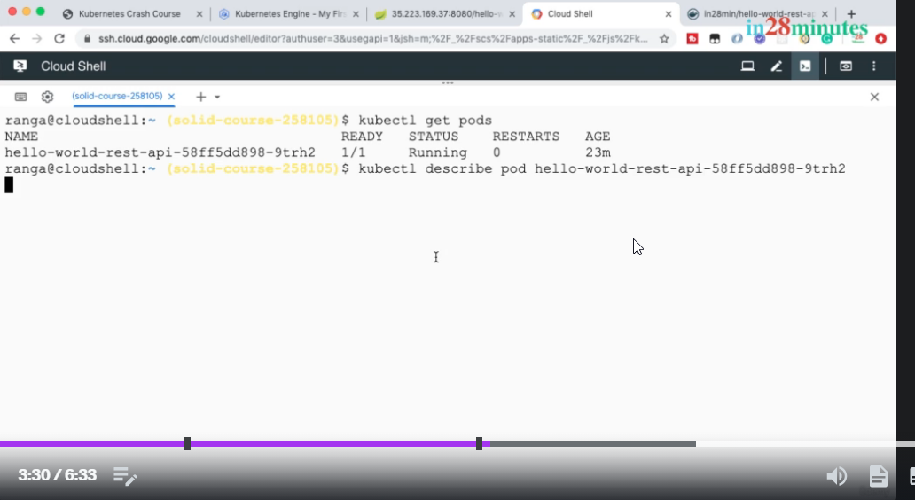

kubectl, get replica sets, - This gives the information about replica sets.

Replica sets ensure that a specific number

of pods are running at all times.

Over here you can see that the desired number

of pods that we want running is one

and currently there is one container in ready status.

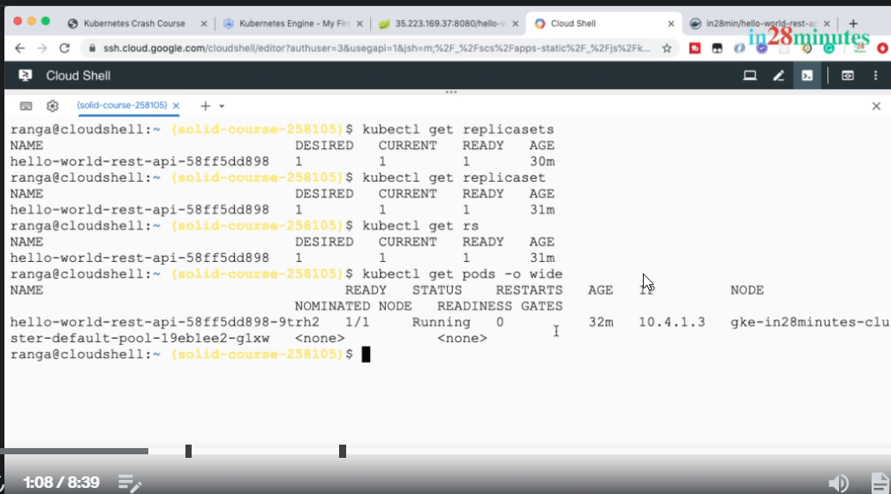

If in the replica set, the desired running pods are 1, and if we kill the pod , then Kubernetes itself creates a replica of that pod and deploy it. And the application is up and running with no to negligible downtime.

If we want to increase the number of pods, then we may increase the replica count by using the below command.

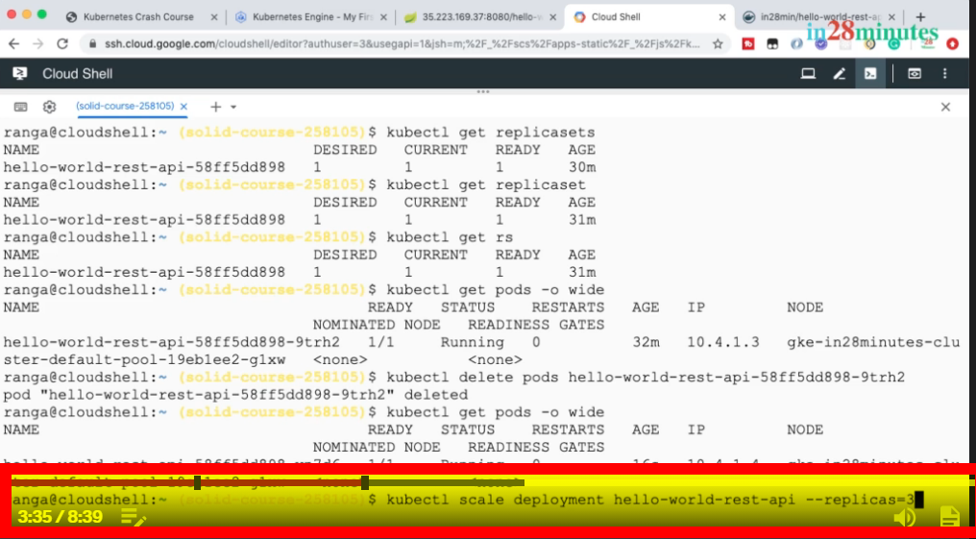

A pod provides a grouping for the containers

and a replica set ensures that a set of pods

a specified number of pods are always running.

When we deploy the new version of pods, the older ones get deleted, and their replicas are also destroyed i.e it automatically scales down the older version.

It ensures that there is zero downtime for these applications.

Replica set is always tied to a particular release version.

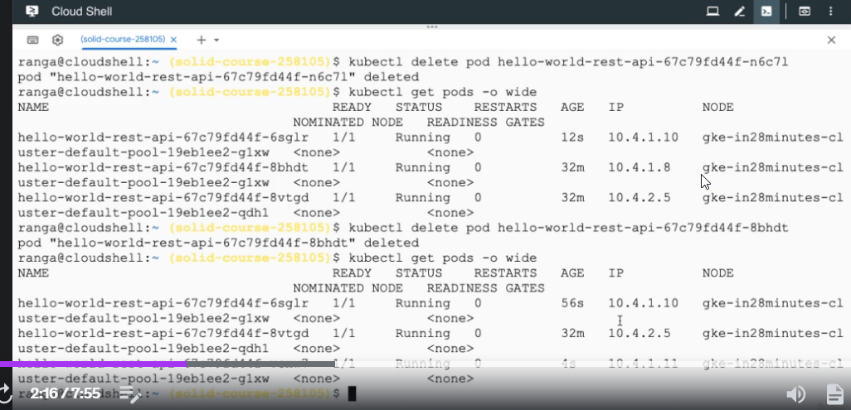

As displayed in the above image, if one pod is deleted, then another pod is created and it has new ip address.

Even if some pods are deleted, still the application will work as it has zero downtime.

In the Kubernetes world, a pod is a throwaway unit.

Your pods might go down, new pods might come up.

Whenever I do a new release,

there might be several new pods that are created,

and the old pods completely go away,

irrespective of all the changes happening with the pods.

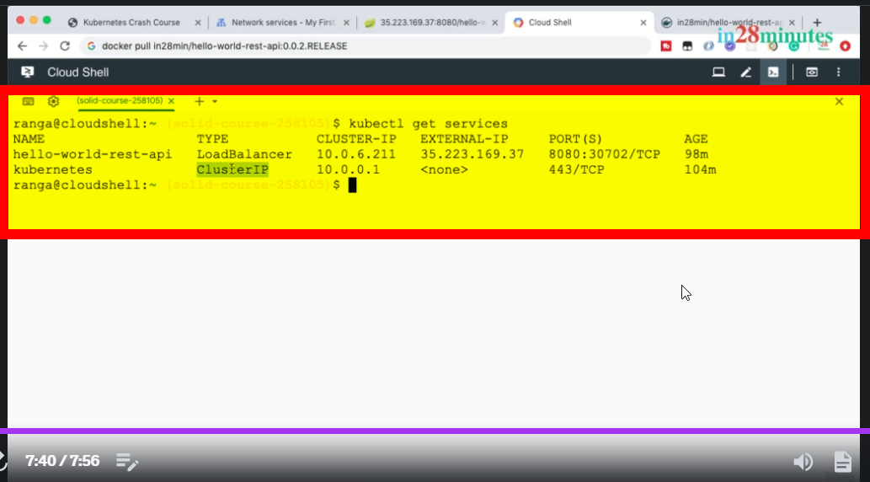

A cluster IP service can only be accessed from inside the cluster.You won't be able to access this service from outside the cluster.You can see that there is no external IP for this specific service.

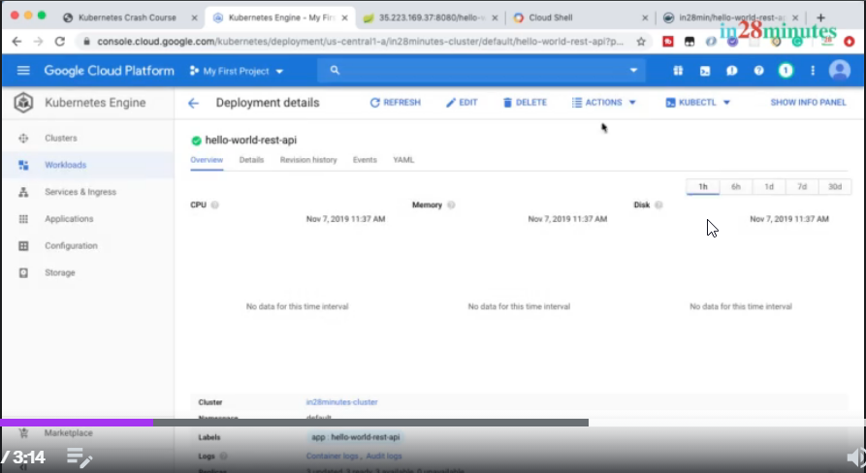

We can edit the deployment and may autoscale , downscale that particular deployment.

Whatever functionality we are able to perform through kubectl command we may also do it through cloud console.

Components of Master Node

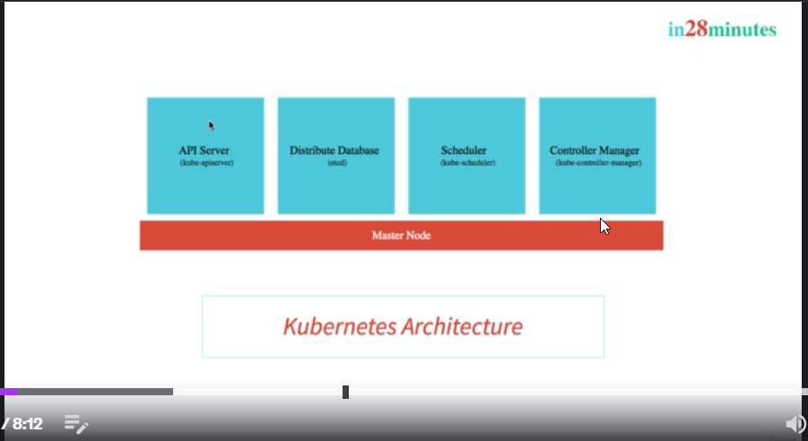

* All the configuration changes that we are making, all the deployments that we are creating, all the scaling operations that we are performing,

all the details of those are stored in a Distributed Database.

* API Server (kube-apiserver) – Any request made through google console or kubectl, it is submitted and processed on this server.
* The scheduler is responsible for scheduling the pods onto the Nodes.In a Kubernetes cluster, you'll have several Nodes and when we are creating a new pod,you need to decide which Node the pod has to be scheduled on to. The decision might be based on how much memories available and how much CPU is available .Are there any pod conflicts and a lot of such factors? So, Scheduler considers all those factors and schedules the pods onto the appropriate Nodes.
* The Controller Manager manages the overall health of the cluster.The kubectl manager makes sure that whatever desired state that we have,

we would want 10 instances of application A,we would want 10 instances of application B,we would want five instances of release 2.All those changes needs to be executed into the cluster and the Controller Manager is responsible for that.It makes sure that the actual state of the Kubernetes cluster matches the desired state.

Components of worker node

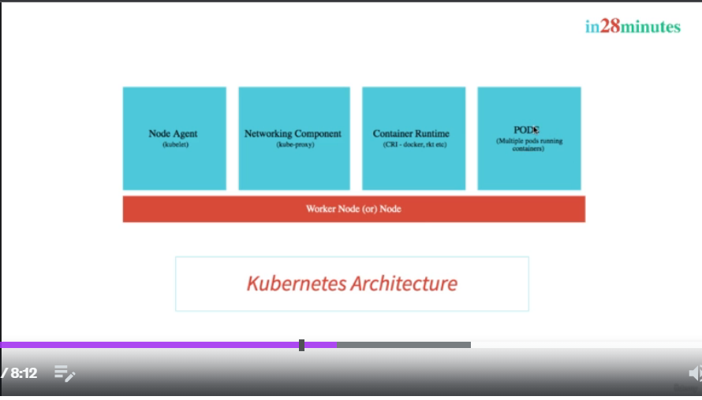

* It contains the pods which contains application which needs to be deployed.
* The other components which are present on the Node are number one, is a Node Agent.It's called a Kubelet. K-U-B-E-L-E-T. The job of a kubelet is to make sure that it monitors what's happening on the Node and communicates it back to the Master Node.
* The other important component of the Worker Node is the Container Runtime.You want to run containers inside our PODS

and these need the Container Runtime.The most frequently used Container Runtime is Docker.

Centralized configuration in Kubernetes can be done with config map.

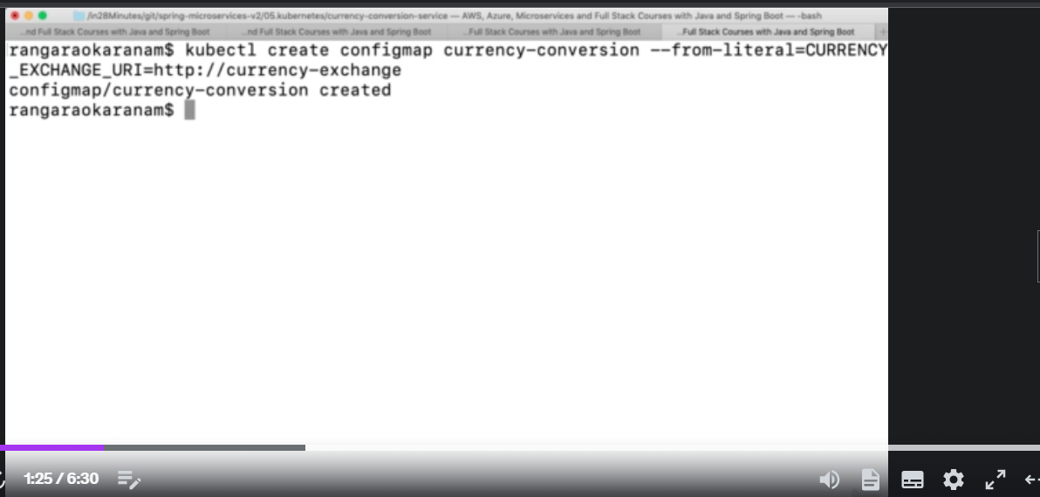

The below command is used to check history of deployment of a microservice.

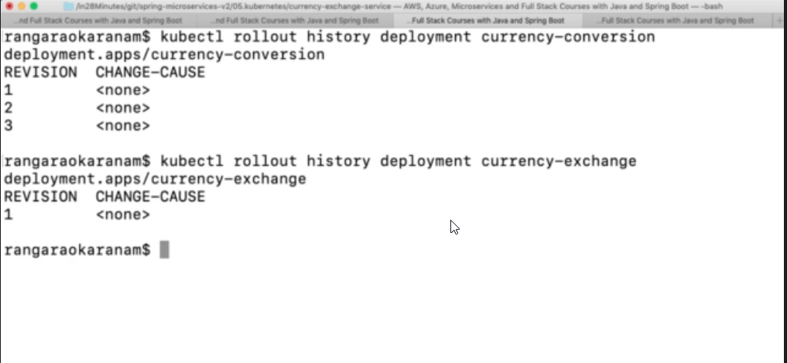



This command is used to deploy application using yaml file which contains configuration.

While using Kubernetes for application deployment, there are downtime of applications sometime in order to avoid that we use liveliness and readiness probes.

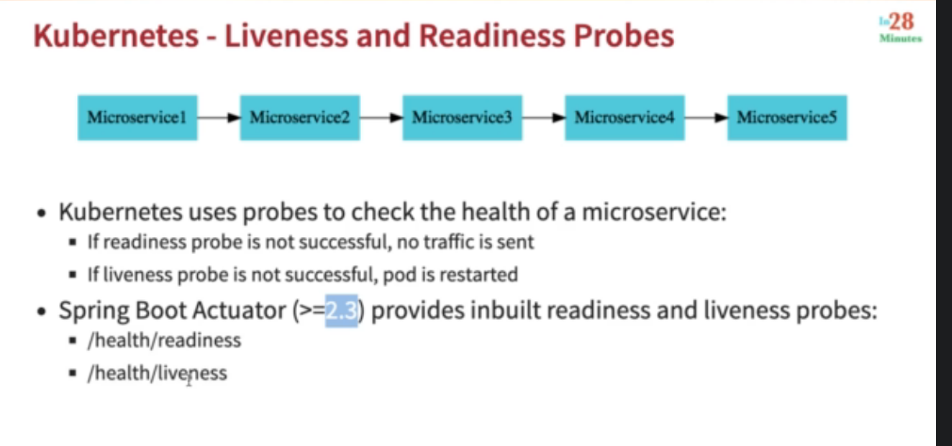

AutoScaling with Kubernetes

The below command can be used to manually scale the microservice.

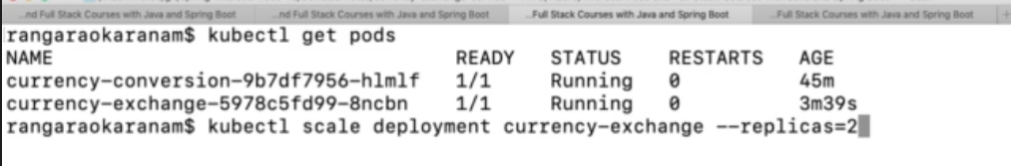

The below command is used to automatically scale the microservice.

Here, min max and cpu-percent is the parameter.

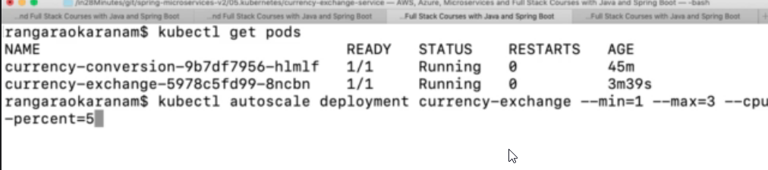

The below-mentioned command is used to check cpu utilization on every node.

